Semester Project

(At the Computer Programming Course)

Duta Alexandru-Vlad

413G

Introduction

For my semester project at Computer Programming Course I chose to develop a currency converter program. A currency converter is a **currency calculator that converts one currency's value or quantity into the relative values or quantities of other currencies**

**The requirement of the problem :**

Each student will create their own program (with a certain degree of assumed originality), which will require the introduction of at least three parameters (variable values) from the keyboard. These parameters (as well as the types of data involved) will be at the student's choice. The program will perform a number of operations and display a final result of these. The source code will contain at least one function, other than the "main" function.  
  
Laboratory and course presented functions may be partially used, but the project must also include an original part, which will be highlighted by the student.  
  
The final presentation will contain:  
  
1. Description of the problem in natural language;  
  
2. Work flow for every function;  
  
3. The listing for entire program (with useful comments);  
  
4. Instances of running the program (screenshots);  
  
5. Indication of the original parts of the program as well as those taken over, in a bibliographic note (with authors, publication, other relevant data), showing all sources of inspiration (including links to used sites).

**Description of the program in natural language**

The program displays a menu for the user and asks to choose from 6 popular currency type from given to convert into Romanian RON,then ask you to insert the amount that you want to convert. In the final, the program calculate and shows the result of the specified conversion.

When the menu is opened, the user is given six option, numbered 1 through 6.

If the introduced value is different from the choices presented,the program will ask you to check you information entered above. At the end it will show a display that ask you if you want to exit with to options, 1(yes) or 2(no).

If the entered data is valid and the type of currency is selected, the program will require entering the amount of money you want to change in Ron.Finally , it displays the result the ,until the user chooses to exit or to make another conversion.

The function "result" is a void function, which means it does not return any value. It takes in three parameters: an integer "num" representing the currency type the user wants to convert, an integer "n" representing the amount of currency the user wants to convert, and a string "ch" representing the name of the currency type.

The function uses a switch statement to determine the conversion rate for each currency type, using the "num" parameter as the variable to switch on. It calculates the total amount of Romanian RON that the given amount of currency will convert to, and then prints the result in the format of "n" currency type = "total" RON. The function does not return any value, it only prints the result.

The function is called within a while loop in the main function, allowing the user to convert multiple currencies without having to restart the program. The program also has the option for the user to exit by entering a value of 1.

The main function in this code is a currency converter that converts various currencies into Romanian RON (Romanian Leu). The program prompts the user to choose a currency type and enter the amount they want to convert. The user is given a list of popular currency types to choose from and is prompted to enter the number and name of the currency type they want to convert. The program then uses a switch statement to determine the conversion rate for each currency type. The result is then displayed in the format of "n" currency type = "total" RON.

**Workflow for each function**

**Void result() function:**

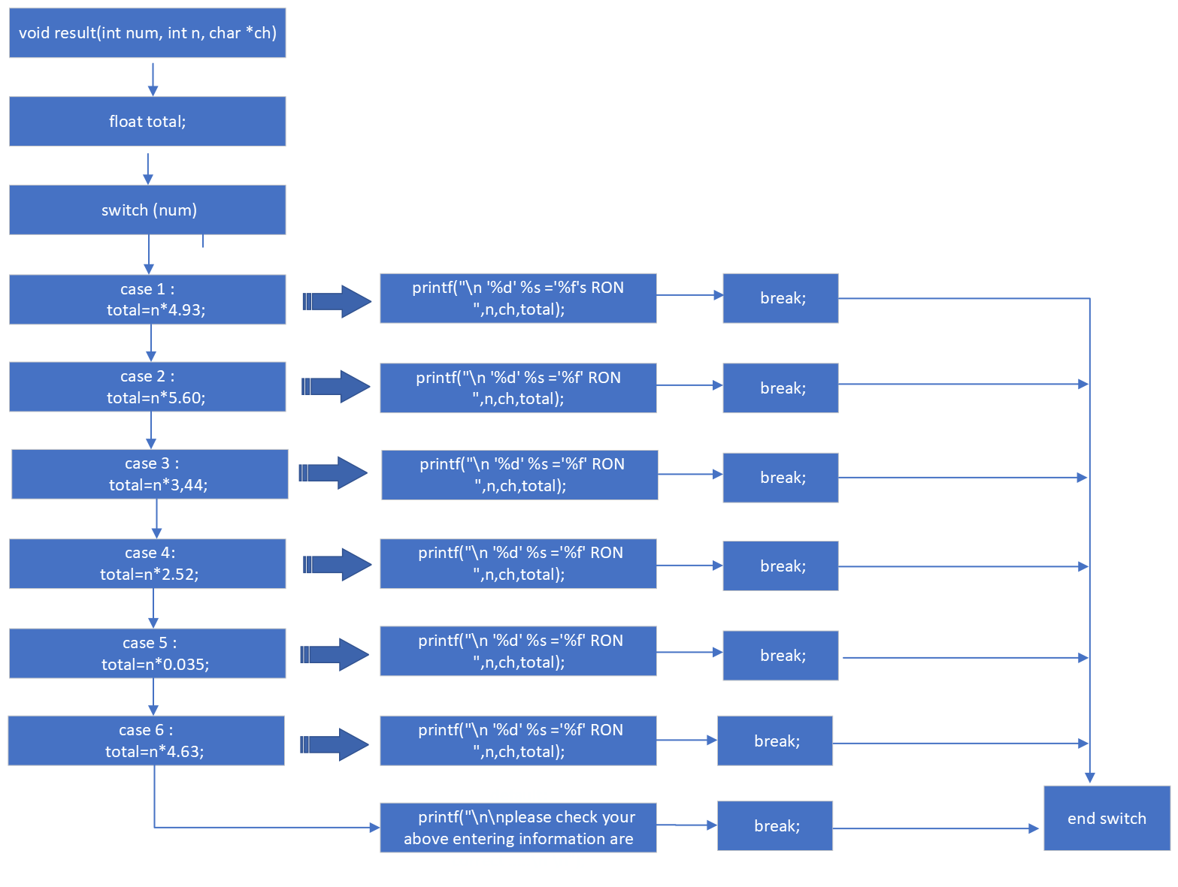

**Main function:**

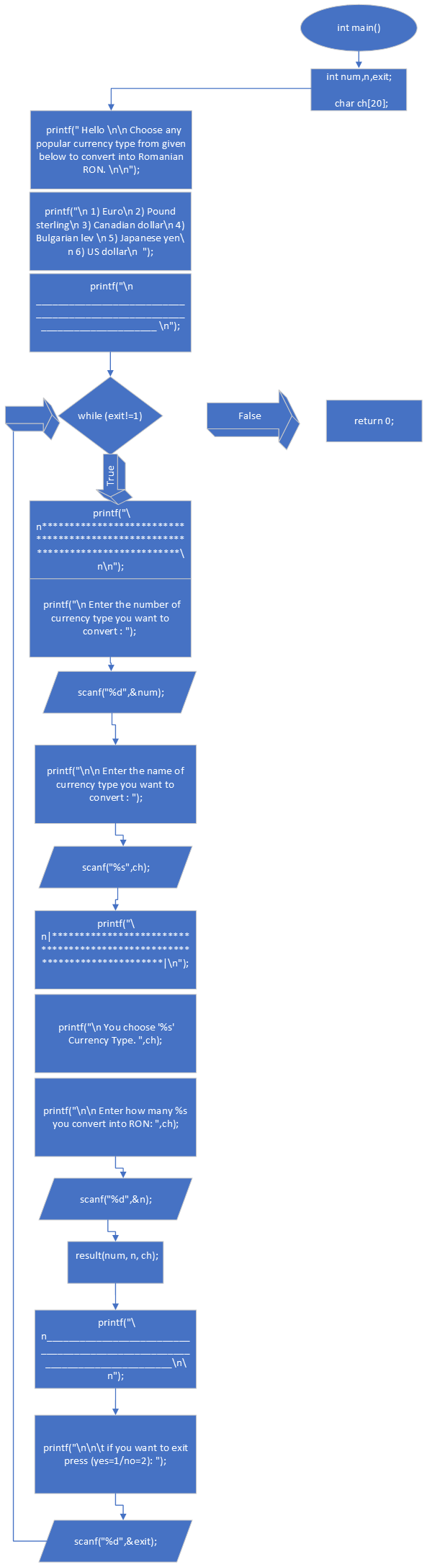

**The listing for the entire program with useful comments**

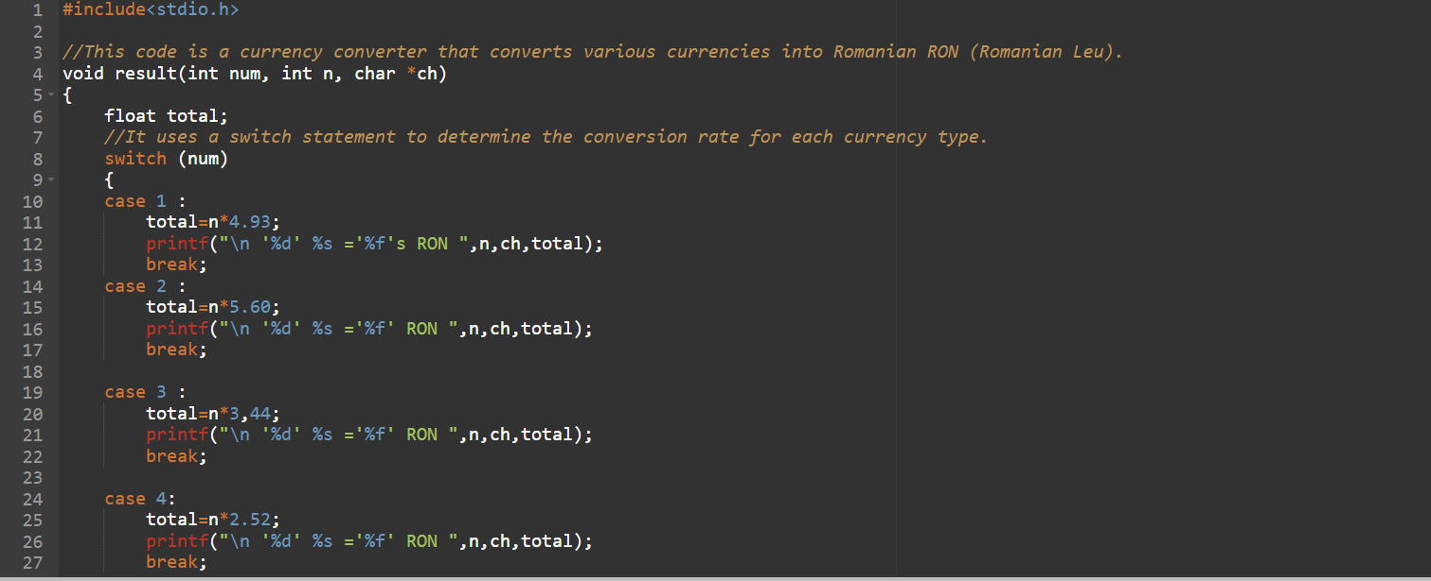

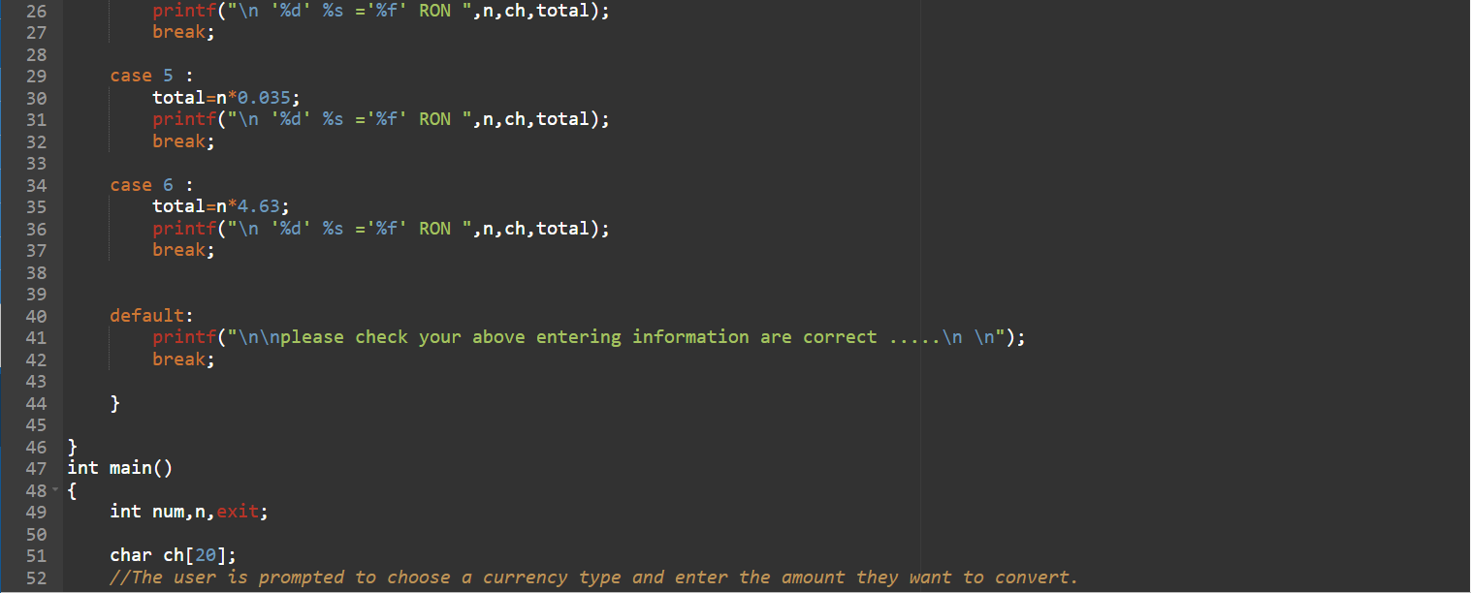

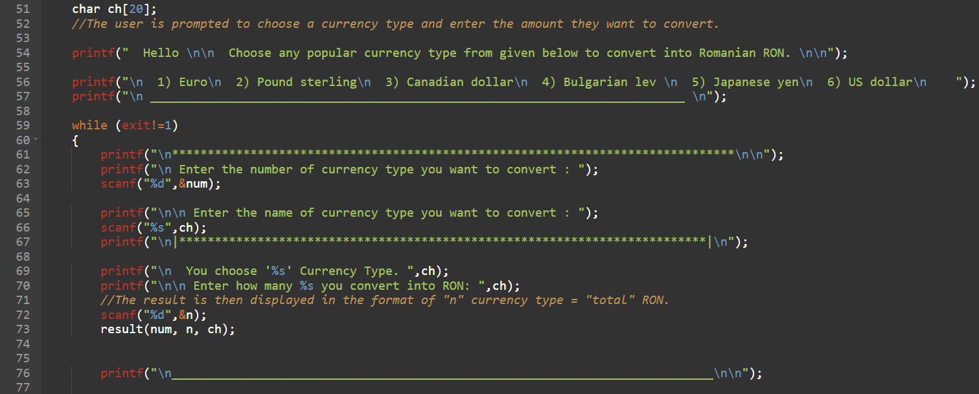

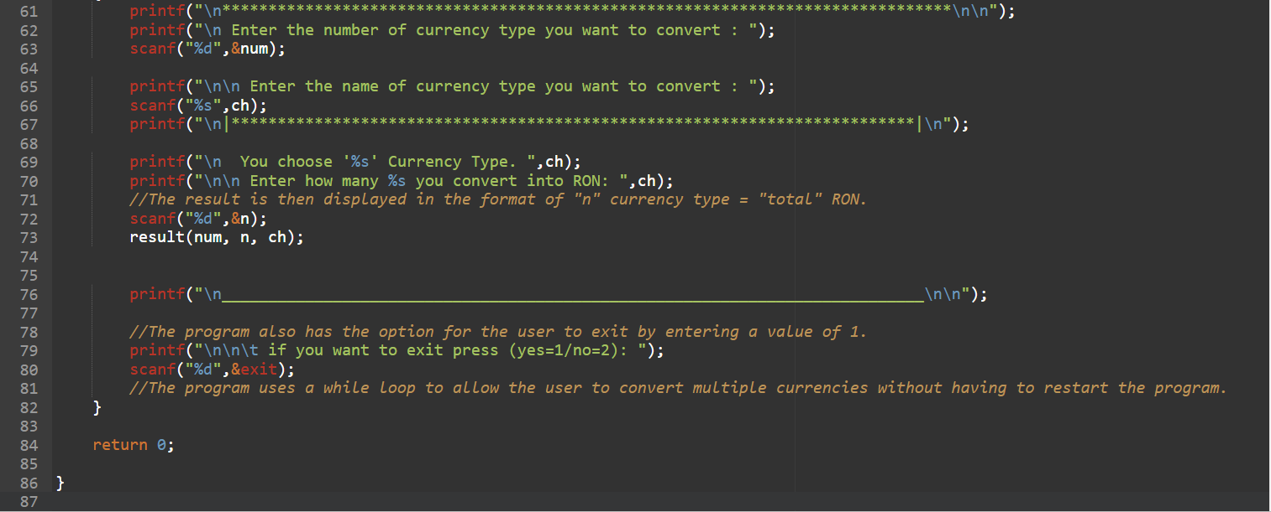

**Instances of running the program**

